**Lampiran 5.A Halaman Detail Laporan**

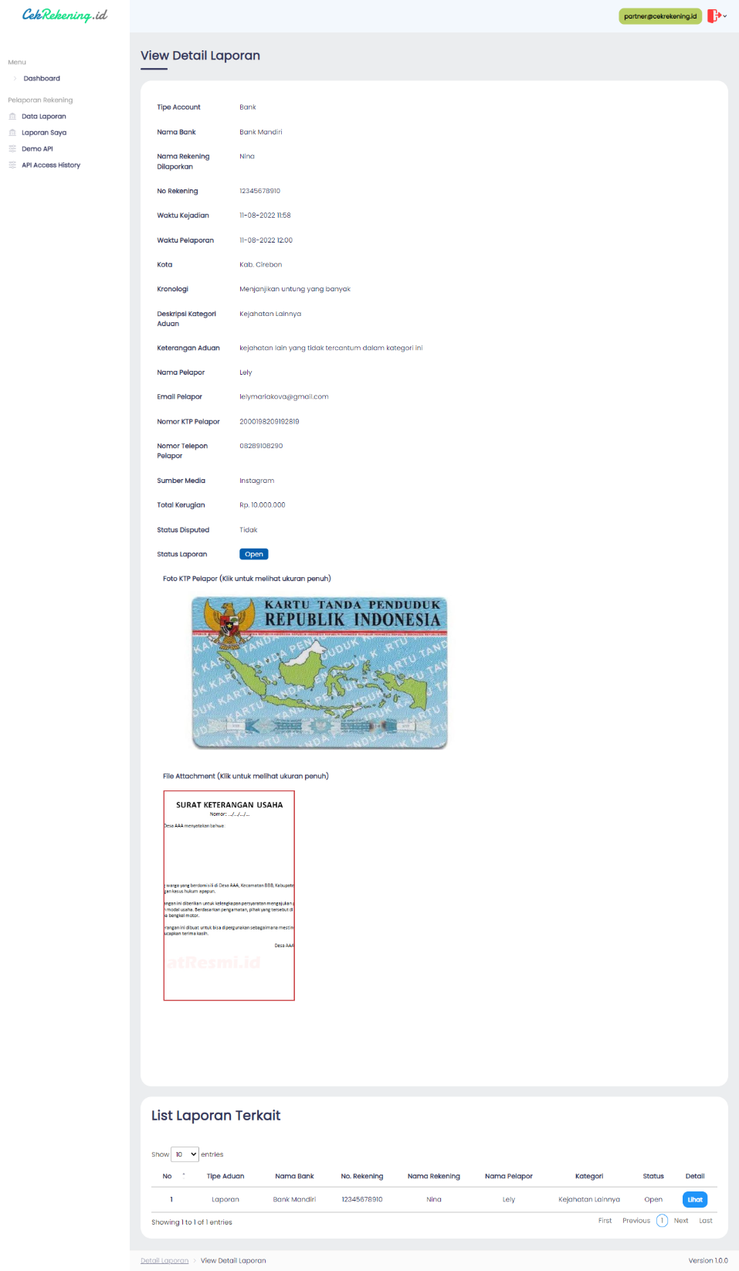

**Lampiran 5.B Halaman Reject Laporan**

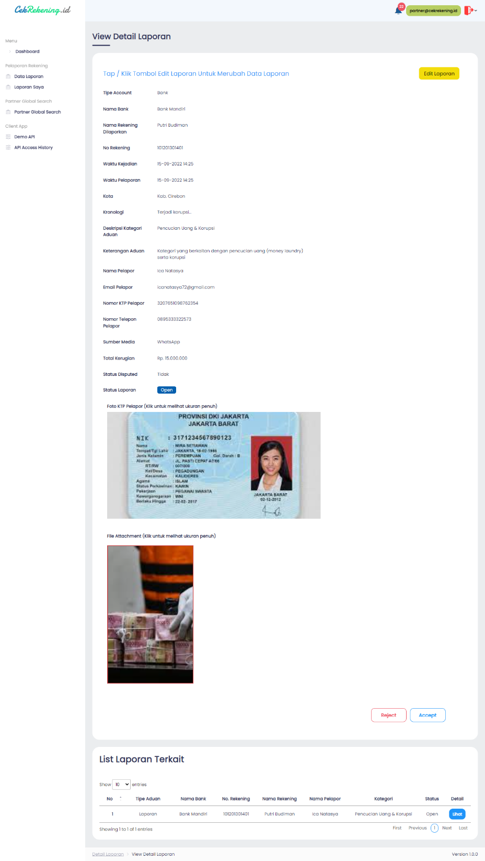

**Lampiran 5.C Halaman Accept Laporan**



**Lampiran 5.D Halaman Demo API**

